## Hand-in Homework #6

### Problem #1: Society of Obstetricians and Gynecologists of Canada, "Parental Screening, Diagnosis, and Pregnancy Management of Fetal Neural Tube Defects."

#### (a)

For prevalence of 1 in 300, calculate PPV and NPV in the best case scenario (detects 90% of NTDs with FPR of 1%).

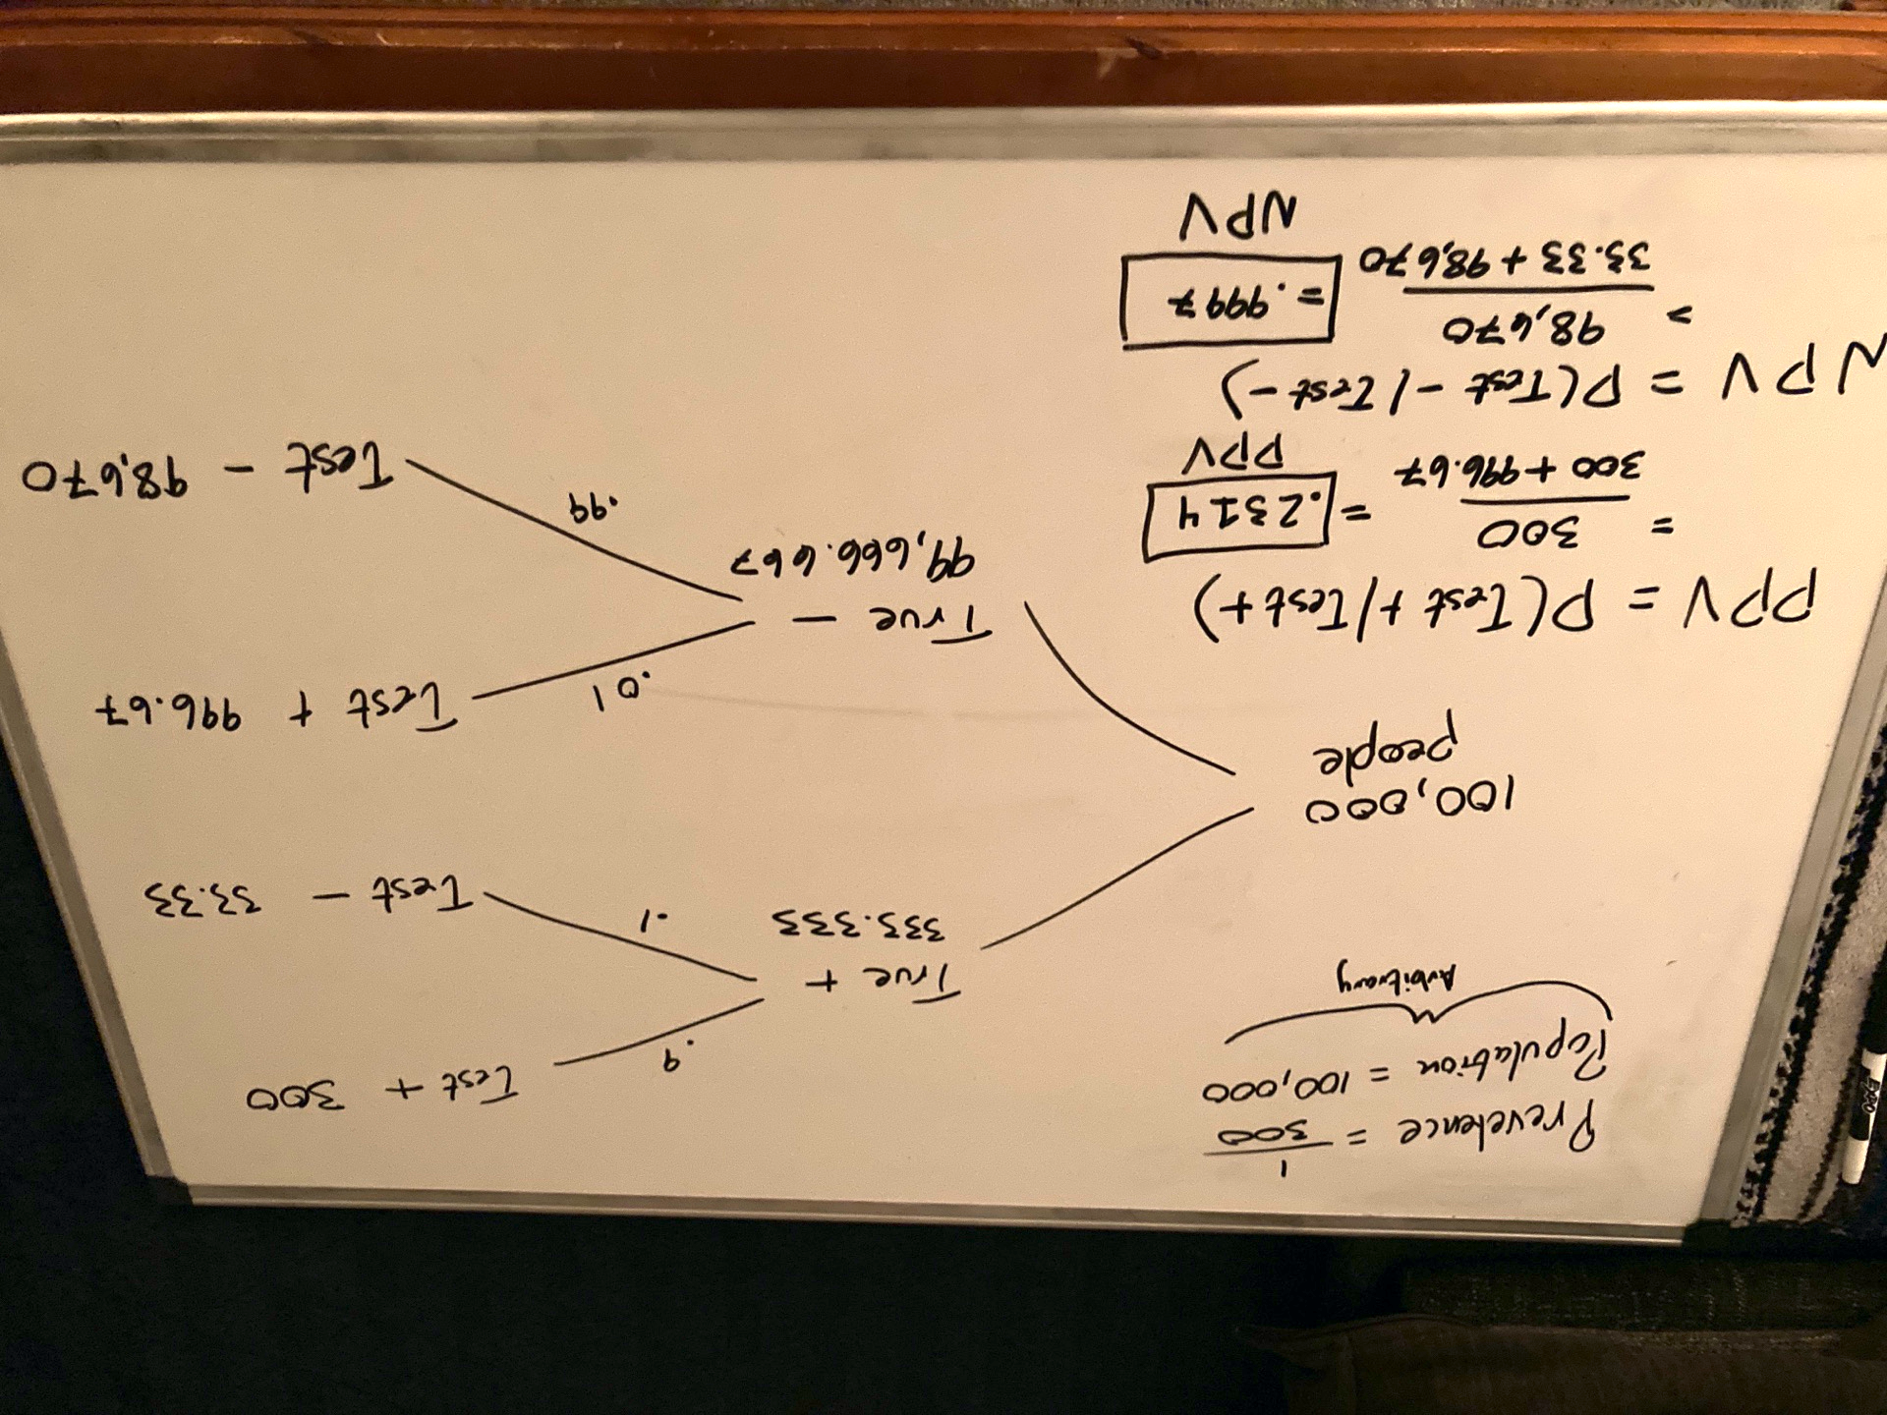

#### (b)

For prevalence of 1 in 300, calculate PPV and NPV in the worst case scenario (detects 71% of NTDs with FPR of 3%).

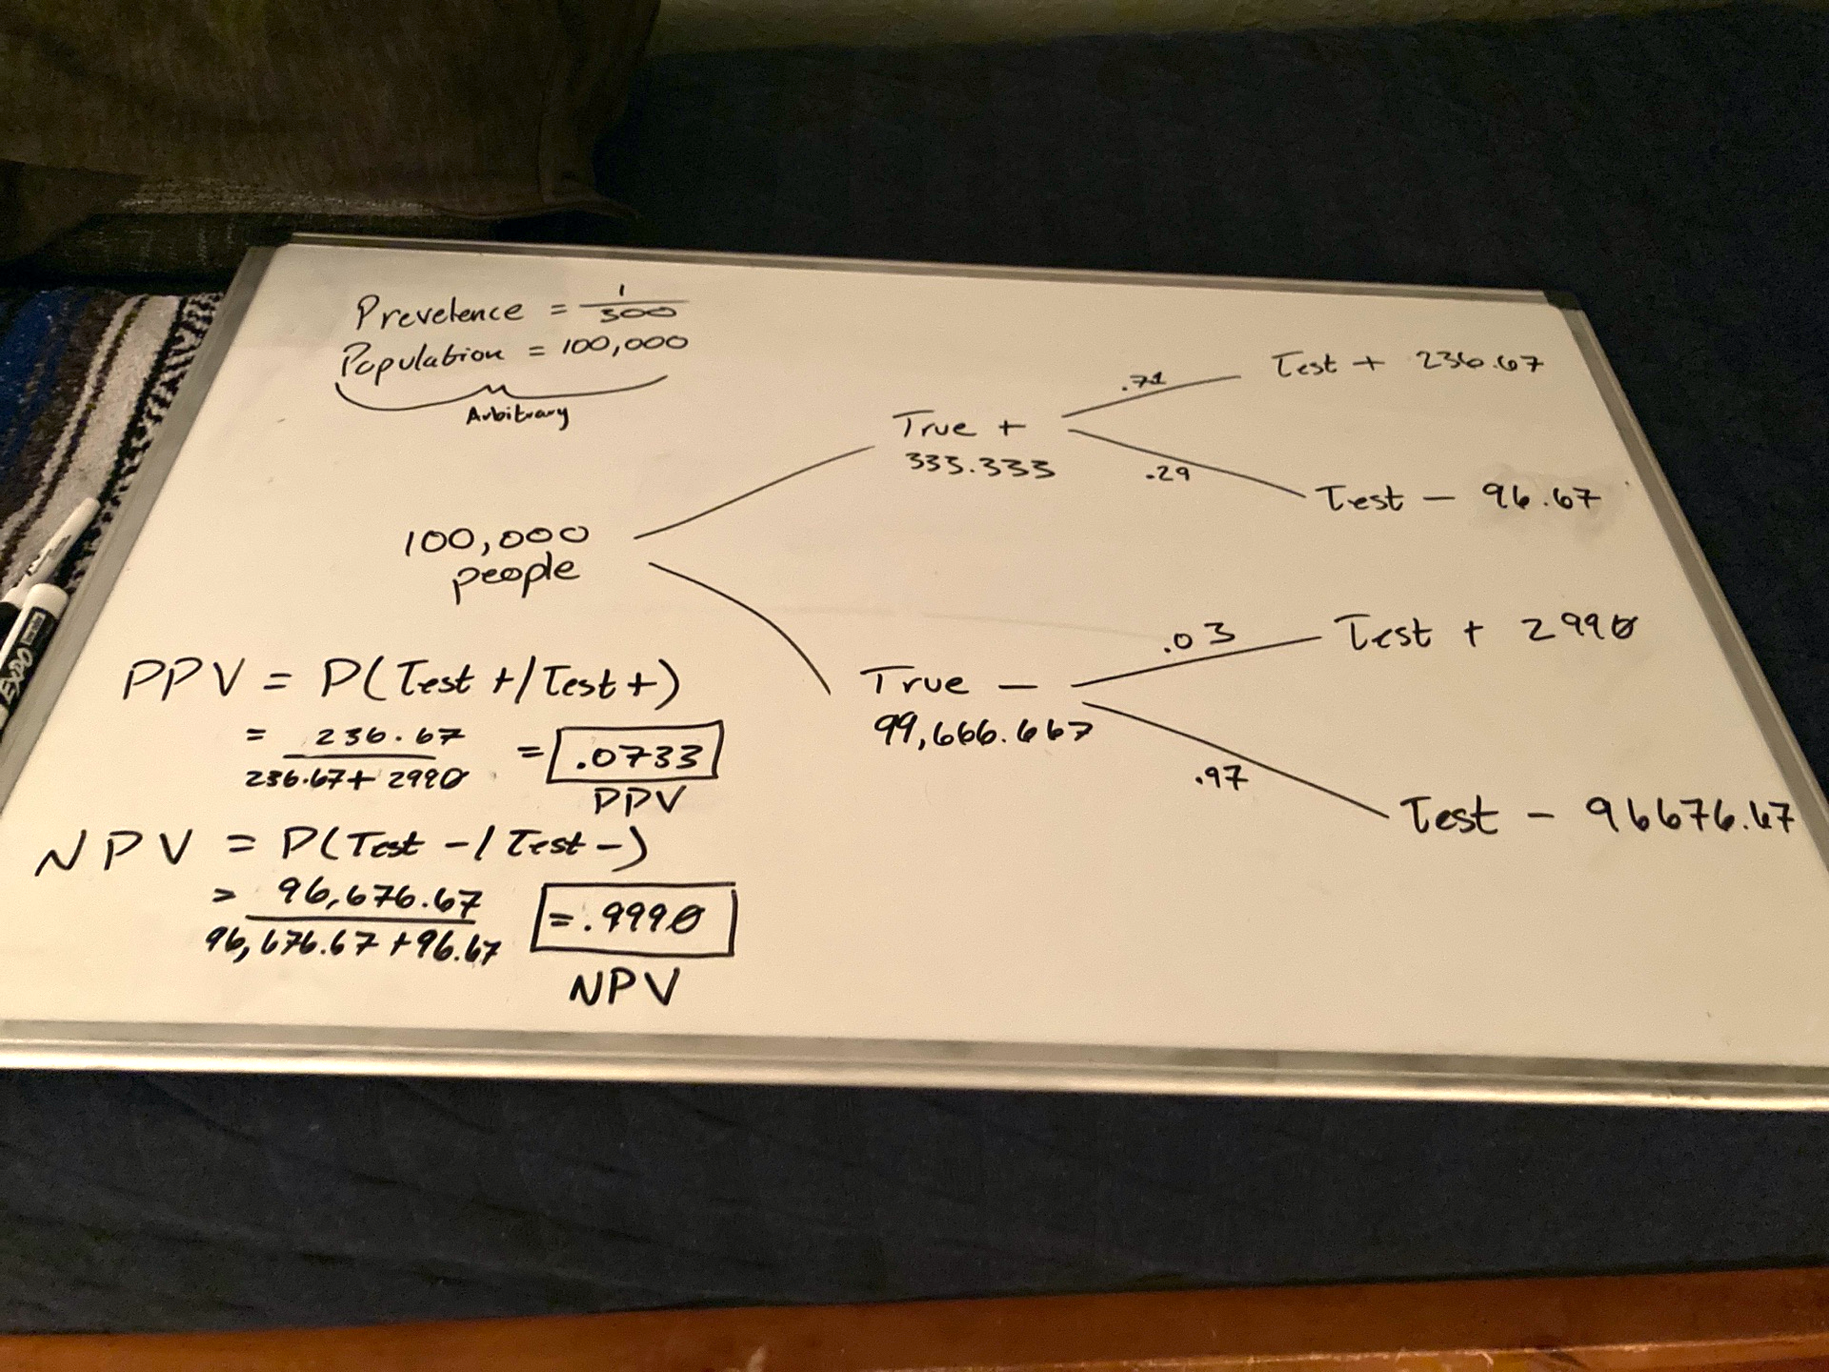

In both cases, show how you arrived at your answers with either a tree diagram with appropriate values or a formula. Round final answers to 4 decimal places. Do not round intermediate

calculations. For example, 1 in 300 is not .0033.

### Problem #3: Part IV Review Exercises (pg. 469-474)

#### R4.12

##### (a) Create a probability model for the outcome on the spinner

##### (b) Find the mean and standard deviation of the spinner results

##### (c) Create a probability model for the outcome of the die.

##### (d) Find the mean and standard deviation of the die results

##### (e) Find the mean and standard deviation of the number of spaces you get to move

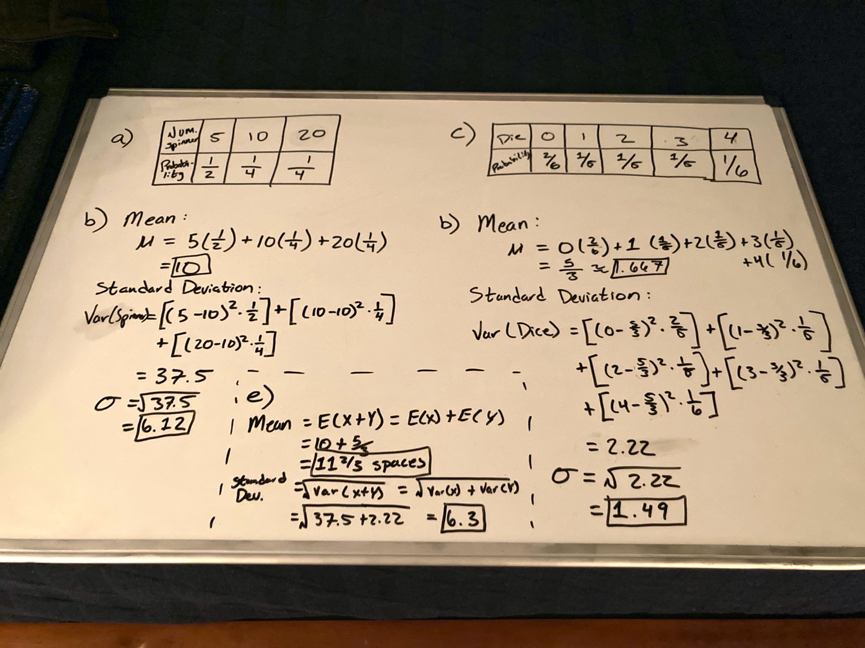

#### R4.14: If you land in a ‘penalty zone’ on the game board described in Exercise 12, your move will be determined by subtracting the roll of the ide from the result on the spinner. Now what are the mean and standard deviation of the number of spots you move.

#### R4.28

##### (a) What’s the mean difference in weights of the melons?

##### (b) What’s the standard deviation of the difference in weights?

##### (c) If a normal model can be used to describe the difference in weights, what’s the probability that the melon you got at the first store is heavier?

